Title of Paper in English

Pisut Koomsap¹, Rui M. Lima², Huynh T. Luong¹, Kanchana Sethanan³, Valquíria Villas-Boas⁴

¹ Asian Institute of Technology, Pathumthani, Thailand
² Department of Production and Systems, ALGORITMI Centre, School of Engineering, University of Minho, Guimarães, Portugal
³ Khon Kaen University, Thailand
⁴ University of Caxias do Sul, Caxias do Sul, Brazil
Email: pisut@ait.asia, rml@dps.uminho.pt, luong@ait.asia, ksethanan@gmail.com, vvillasboas@gmail.com

Abstract
This document should be used as a template for the papers submitted to PAEE/ALE’2020. It provides the intended general structure and format, as well as other relevant information. Please read the template contents carefully and follow the instructions. In order to preserve the styles and other formatting elements, copy your text into this template. Papers can be written in English. The abstract should not exceed 300 words, followed by two to four keywords. The full paper is expected to have six to eight pages.
Keywords: Active Learning; Engineering Education; Conference Information; Project Approaches.

Introduction
This document is to be used as a template for the paper. It gives information on its general structure and format and uses general information on the conference to explain that. Save this document and copy your own text into this template. The paper can be written in English.
The demand for engineering professionals is characterised by requirements of deep and solid interdisciplinary technical and transversal competences. Changing Engineering programmes (Graaff & Kolmos, 2007) to meet these requirements can be addressed by different active learning approaches (Christie & de Graaff, 2017; Lima, Andersson, & Saalman, 2017) and several institutions of higher education have been addressing these requirements with project approaches to engineering education. Problem and Project-Based Learning approaches (Edström & Kolmos, 2014; Graaff & Kolmos, 2003; Helle, Tynjälä, & Olkinuora, 2006) have proven to be effective in making interdisciplinary connections between different subject matters, developing, in parallel, competences of project management, autonomy and communication (Lima, Dinis-Carvalho, Flores, & Hattum-Janssen, 2007; Powell & Weenk, 2003).
PAEE/ALE'2020 is an international conference on active learning in engineering education, aiming to be a place for teachers, researchers, and professionals specializing in Engineering Education to meet annually to exchange, share, and discuss ideas to enhance engineering education with Active Learning. Besides paper sessions, participants will experience active involvement in hands-on sessions, workshops, debates, round table, poster sessions, and student project sessions. The conference is the merging of two international events: the International Symposium on Project Approaches in Engineering Education (PAEE) organized by the PAEE association and the Department of Production and Systems of the University of Minho, Portugal, since 2009, and Active Learning in Engineering Education Workshop (ALE) organized by Active Learning in Engineering Education Network since 2000. This event joins together the 12th International Symposium on Project Approaches in Engineering Education (PAEE'2020) and the 17th Active Learning in Engineering Education Workshop (ALE'2020). PAEE/ALE'2020 will be the fifth collaboration of the two events.
The PAEE/ALE’2020 is hosted by the Asian Institute of Technology, Thailand, and will take place at the Brighton Grand Hotel (https://pattaya.brightonhotelgroup.com/), Pattaya, Thailand (Figure 1).
More information can be found at the conference website: http://paeeale.ait.ac.th/.

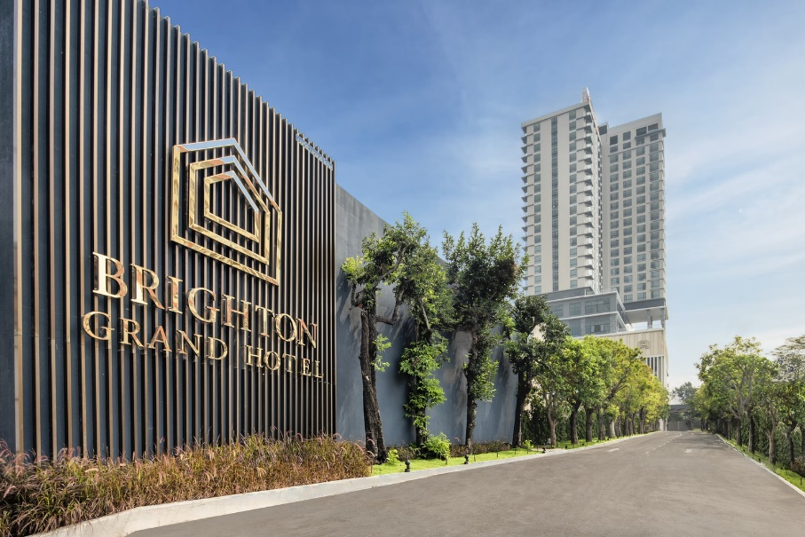
Figure 1. Image of Brighton Grand Hotel at Pattaya.

Scope
This conference will be based on different types of interaction approaches, namely: (i) paper sessions (regular sessions, debate sessions and students paper award), (ii) hands-on sessions, (iii) workshops and (iv) interactive poster session. On paper sessions, debate sessions and students award, participants can share their work and proposals. The hands-on sessions and workshops involve small groups working as teams and enable for extensive discussions and exchange of experiences with international experts.

Conference organisation model
The following themes are proposed, but PAEE/ALE’2020 is open to suggestions for other topics related to project approaches in engineering education:
- Active Learning and ICT support
- Attracting young people to Engineering
- Basic sciences in engineering education
- Curriculum design
- Development and assessment of competences
- Diversity in Engineering students
- Education for sustainability
- Evaluating PBL and Active Learning
- Implementation of pedagogic changes
- Innovative experiences in engineering education
- Interdisciplinarity
- Project management in engineering education
- Research on PBL and Active Learning
- Serious games
- Student assessment in PBL and Active Learning
- Student engagement in learning
- Teacher and tutor roles in PBL and Active Learning
- Teamwork
- University-Business Cooperation
- Workspaces for Active Learning
The programme diversity, in terms of interaction approaches and addressed themes, make the PAEE/ALE a platform for those who wish to share and learn more about active learning and project oriented approaches to teaching/learning of engineering.

Milestones – important dates
The conference has the milestones indicated in Table 1. Please note that the tables should be formatted as below, without vertical borders.
Table 1. Milestones – important dates.
Date | Milestones
March 1, 2020 | Abstract submission for full papers
March 21, 2020 | Notification of abstract acceptance
April 15, 2020 | Full paper submission
April 30, 2020 | Abstract only submission
May 21, 2020 | Notification of acceptance
June 5, 2020 | Camera-ready submission for full papers
June 21, 2020 | Early registration

Target Stakeholders
PAEE/ALE conference aims to engage teachers, researchers on Engineering Education, deans of Engineering Schools and professionals concerned with Engineering Education in the discussion of Active Learning and Project Approaches in Engineering Education through active workshops and presentations of current practice and research in this field.

Information for Participants
This section has information relevant for participants in terms of: (i) web platform registration, (ii) conference registration and (iii) instructions for authors.

Web Platform Registration
Web platform registration is free and does not necessarily require a conference registration. All participants should register at the Easychair platform (https://easychair.org/conferences/?conf=paeeale2020) in order to get a login and password to have access to the submission platform. Different roles will be assigned to participants, authors, reviewers and organisation members. Abstracts and papers must be submitted using the Easychair web platform. Please register on the web platform to submit abstracts/papers.

Conference Registration
Conference registration is compulsory for PAEE/ALE’2020 participants. Papers will only be published after registration and payment of the registration fee. At least one of the authors is required to register and present the paper.
Please find more information on conference registration and payment on the conference website (http://paeeale.ait.ac.th/). Participants not presenting a paper are also welcome to PAEE/ALE’2020.

Instructions for Authors
Papers submitted to the conference must be in accordance with this document, which should be used as a template by the authors. Papers are required to have a minimum of six pages and a maximum of eight pages.
This document is in accordance with the following general rules:
- Document file must be in Microsoft Word format applying the styles used in this template.
- Page layout in A4 size with one column text format.
- Entire document written using “Segoe UI” text font.
- Left and right margins of 2 cm; top and bottom margins of 2.5 cm.
- Word style “Normal”: Body text with “Segoe UI” text font size 10, single line spacing, justified, spacing after paragraph 6 pts.
- Title must use the word style “Head_Title”: Title using “Segoe UI” text font, bold, size 16, left aligned.
- Word style “Authors”: Author information with “Segoe UI Light” text font, bold, size 10, left aligned.
- Word styles “affiliation” and “email”: Affiliation and email addresses with “Segoe UI” text font, size 8, left aligned.
- Word style “Heading 1”: First level section titles with “Segoe UI” text font, bold, size 14, distance before paragraph of 24 pts and hanging indent of 0.76 pts.
- Word style “Heading 2”: Second level section titles with “Segoe UI” text font, bold, size 12, distance before paragraph of 10 pts and hanging indent of 1.02 pts.
- Word style “Heading 3”: Third level section titles with “Segoe UI” text font, bold, size 10, distance before paragraph of 10 pts and hanging indent of 1.27 pts.
- Do not use section titles of level 4 and more.
- Do not use footnotes.
- Figure and table captions with “Segoe UI” text font, size 9. Figures and Tables are left aligned.
- References use APA style:
  - Cross reference has “author (year)” or (author, year).
  - Reference list sorted by last name.
Please follow the standards above to format your document, including word styles. Copy your text into this template, in order to comply with the standards.

Conclusion
This document is a quick reference guide for submission of full papers. It also gives some information about the conference in general. If you have any questions or need any further information, do not hesitate to contact the organising committee http://paeeale.ait.ac.th/.

References
Christie, M., & de Graaff, E. (2017). The philosophical and pedagogical underpinnings of Active Learning in Engineering Education. European Journal of Engineering Education, 42(1), 5-16. doi:10.1080/03043797.2016.1254160
Edström, K., & Kolmos, A. (2014). PBL and CDIO: complementary models for engineering education development. European Journal of Engineering Education, 39(5), 539-555. doi:10.1080/03043797.2014.895703
Graaff, E. d., & Kolmos, A. (2003). Characteristics of Problem–Based Learning. International Journal of Engineering Education, 19(5), 657-662.
Graaff, E. d., & Kolmos, A. (Eds.). (2007). Management of Change: Implementation of Problem-Based and Project-Based Learning in Engineering. Roterdam: Sense Publishers.
Helle, L., Tynjälä, P., & Olkinuora, E. (2006). Project-Based Learning in Post-Secondary Education - Theory, Practice and Rubber Sling Shots. Higher Education, 51(2), 287-314.
Lima, R. M., Andersson, P. H., & Saalman, E. (2017). Active Learning in Engineering Education: a (re)introduction. European Journal of Engineering Education, 42(1), 1-4. doi:10.1080/03043797.2016.1254161
Lima, R. M., Dinis-Carvalho, J., Flores, M. A., & Hattum-Janssen, N. v. (2007). A case study on project led education in engineering: students' and teachers' perceptions. European Journal of Engineering Education, 32(3), 337 - 347.
Powell, P. C., & Weenk, W. (2003). Project-Led Engineering Education. Utrecht: Lemma.

